**AWS DAY 3 and DAY 4 ASSIGNMENT**

PROJECT 1:

Deploying a web server in Windows instance

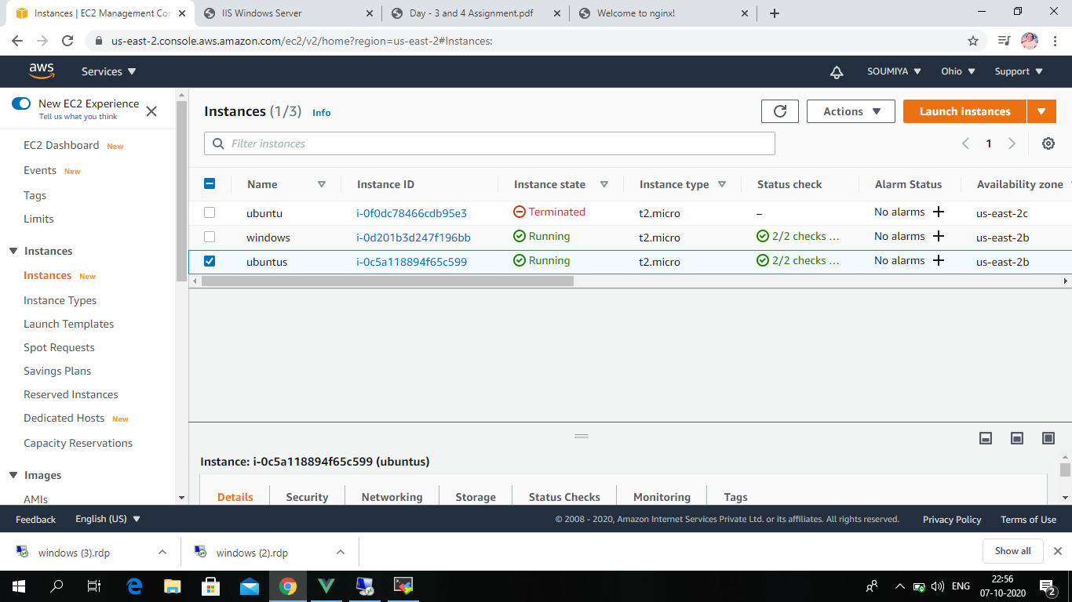

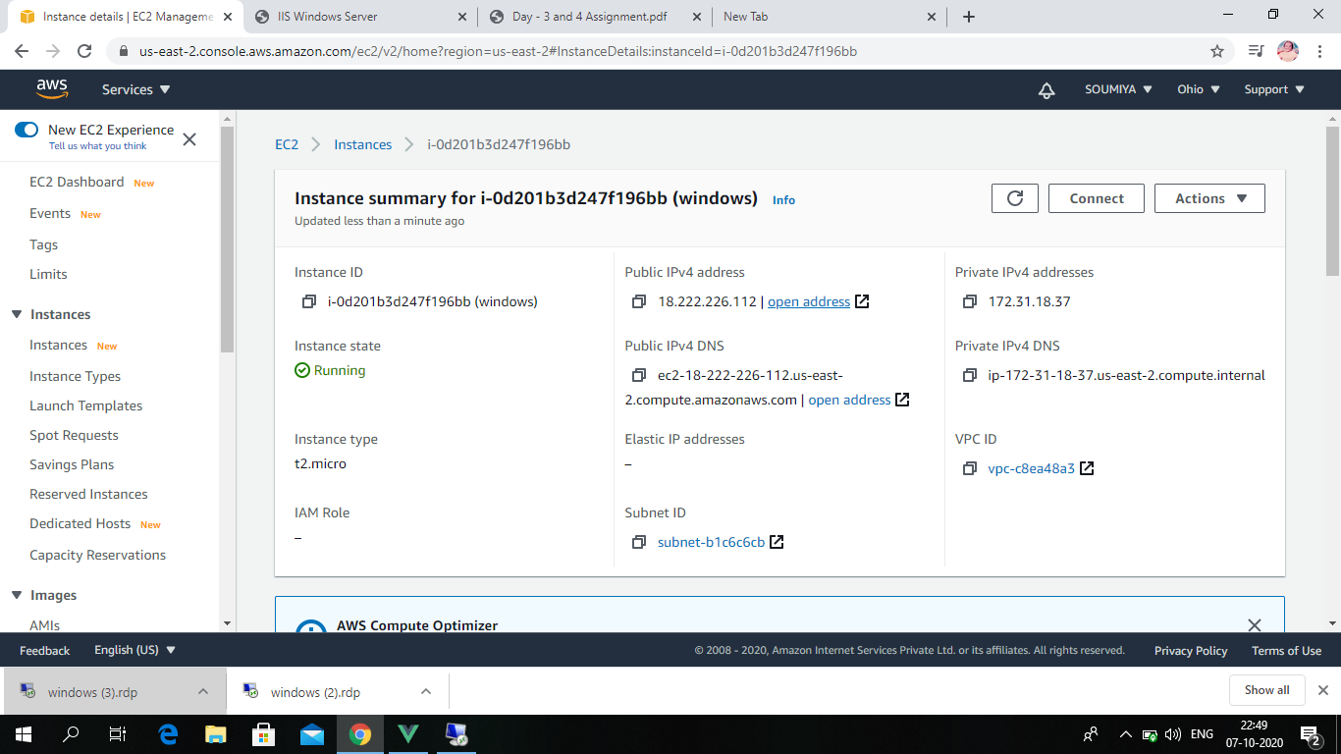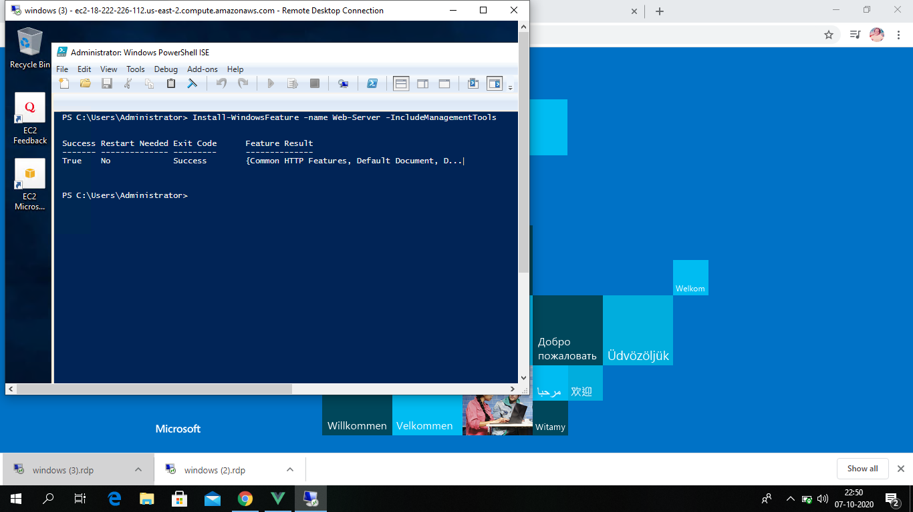

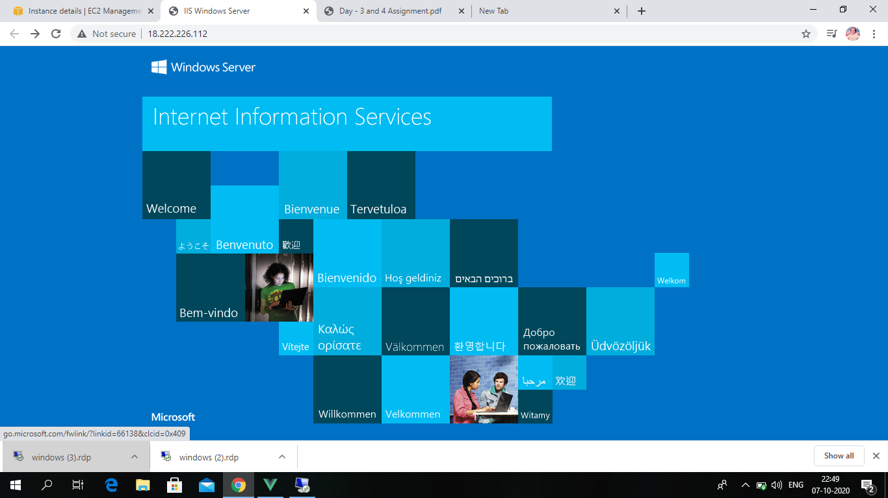

PROJECT 2:

Deploying a web server in Windows instance



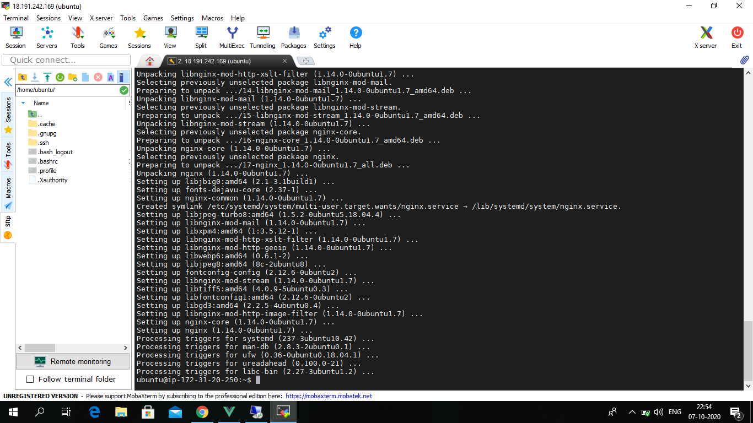

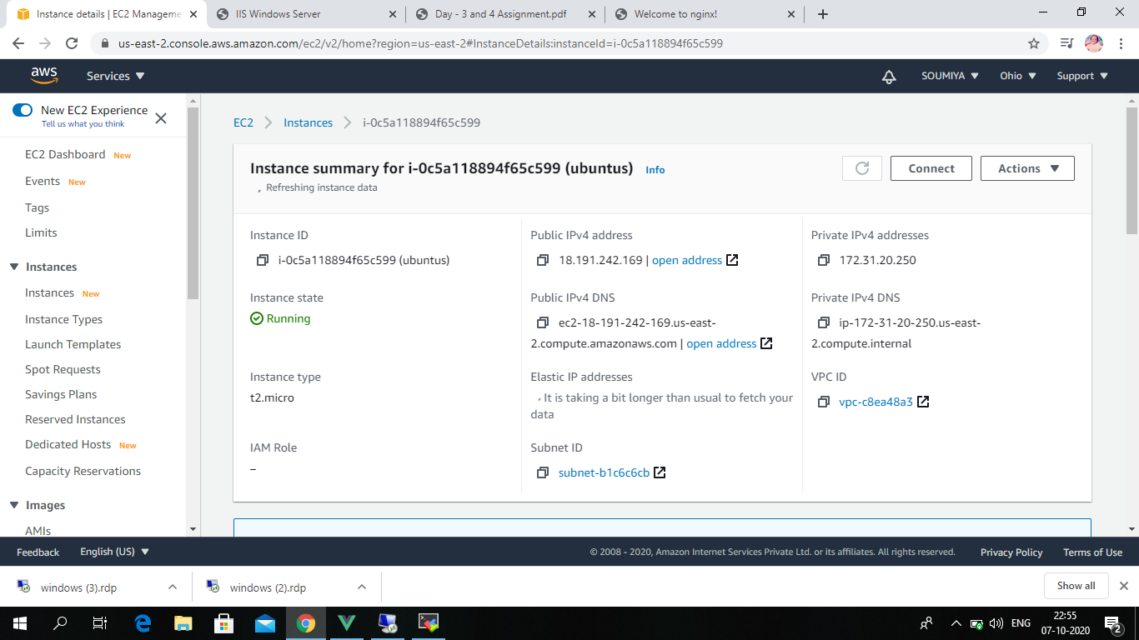

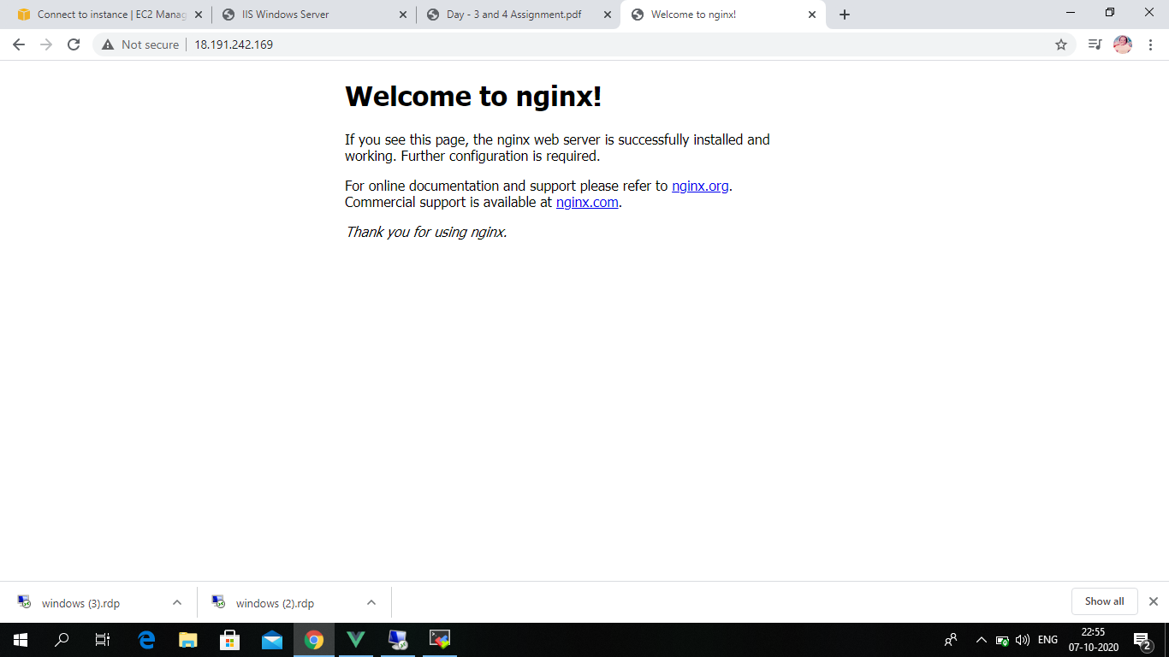

PROJECT 3:

Working with volumes

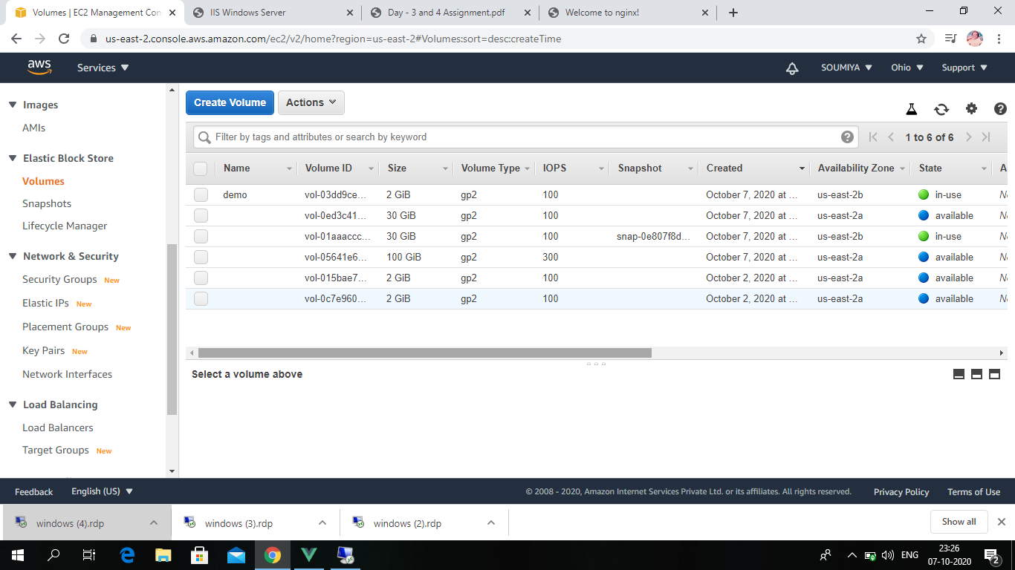

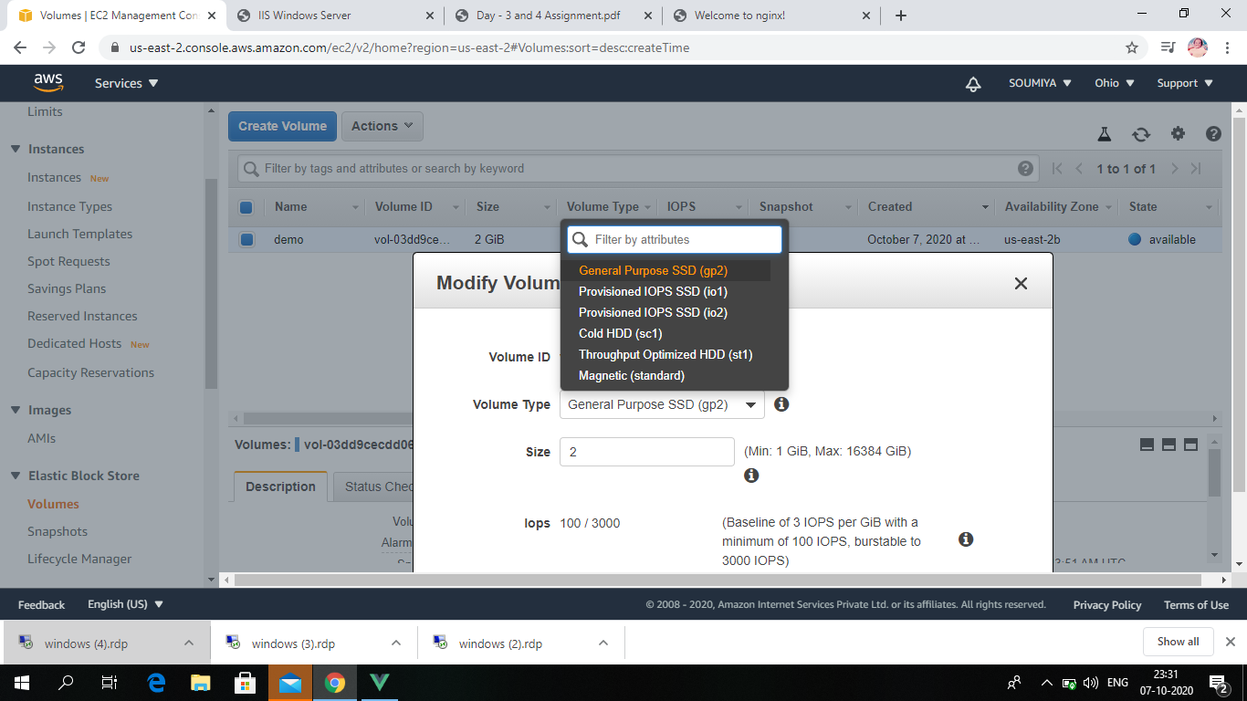

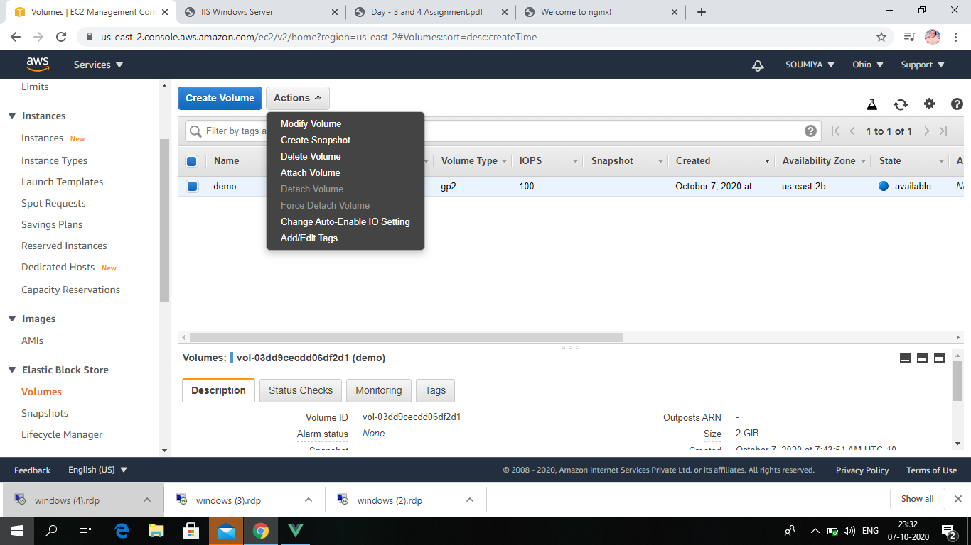

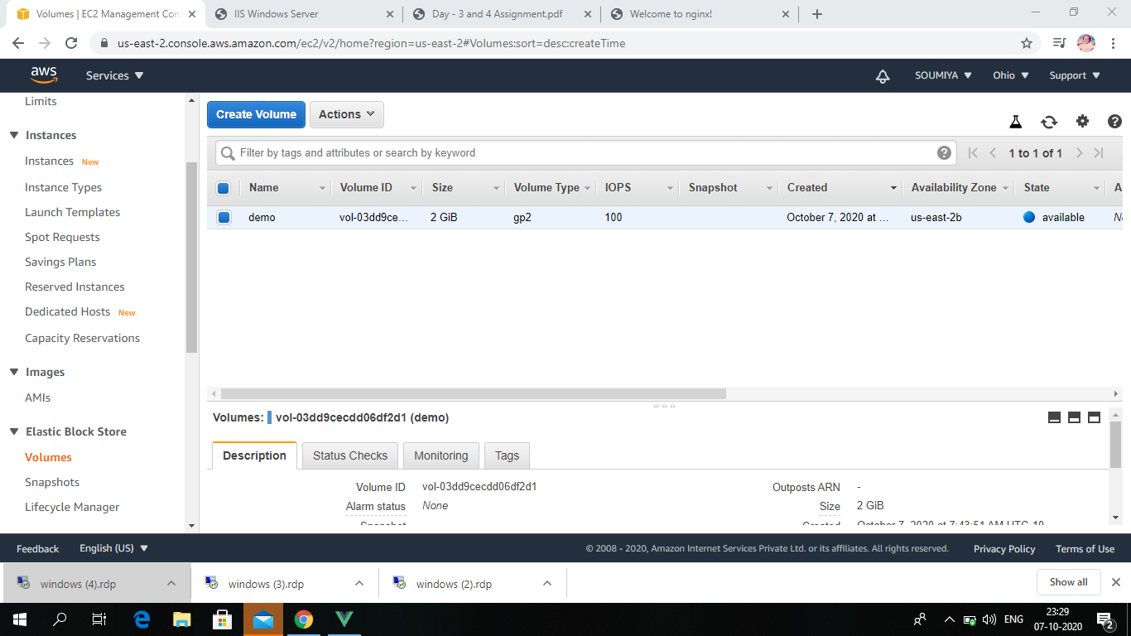

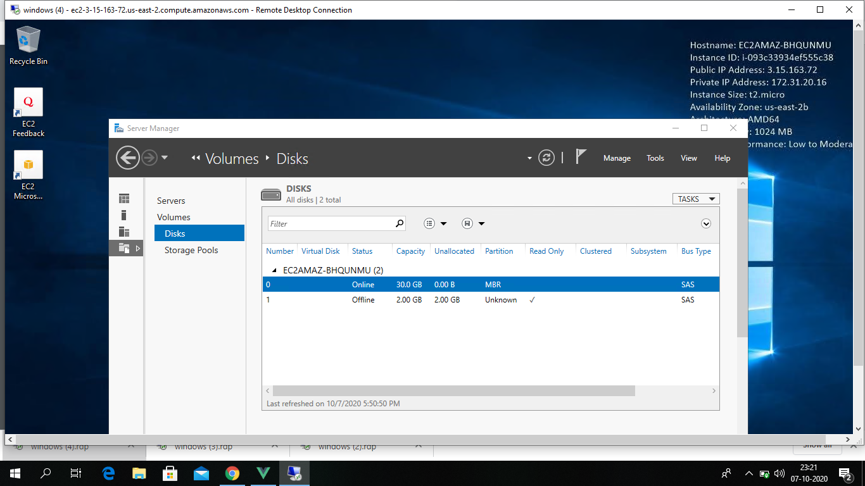

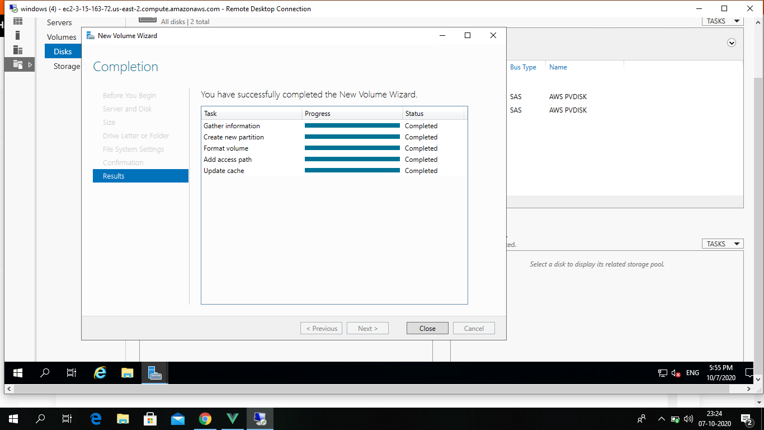

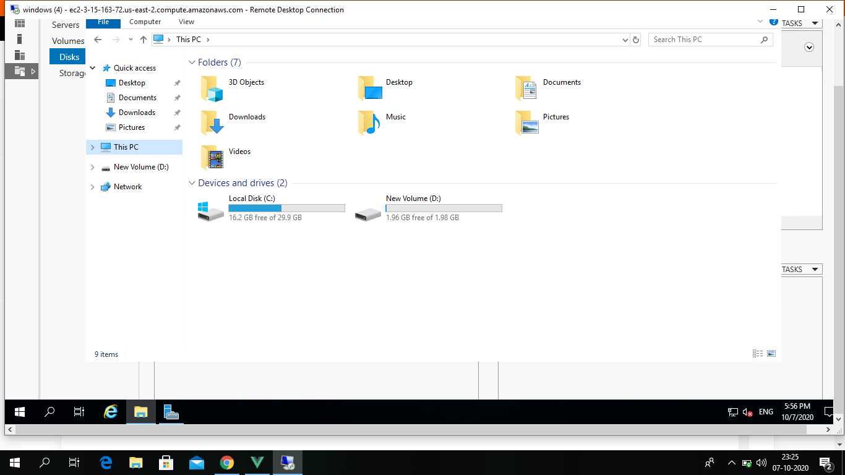

PROJECT 4:

Working with Elastic IP's

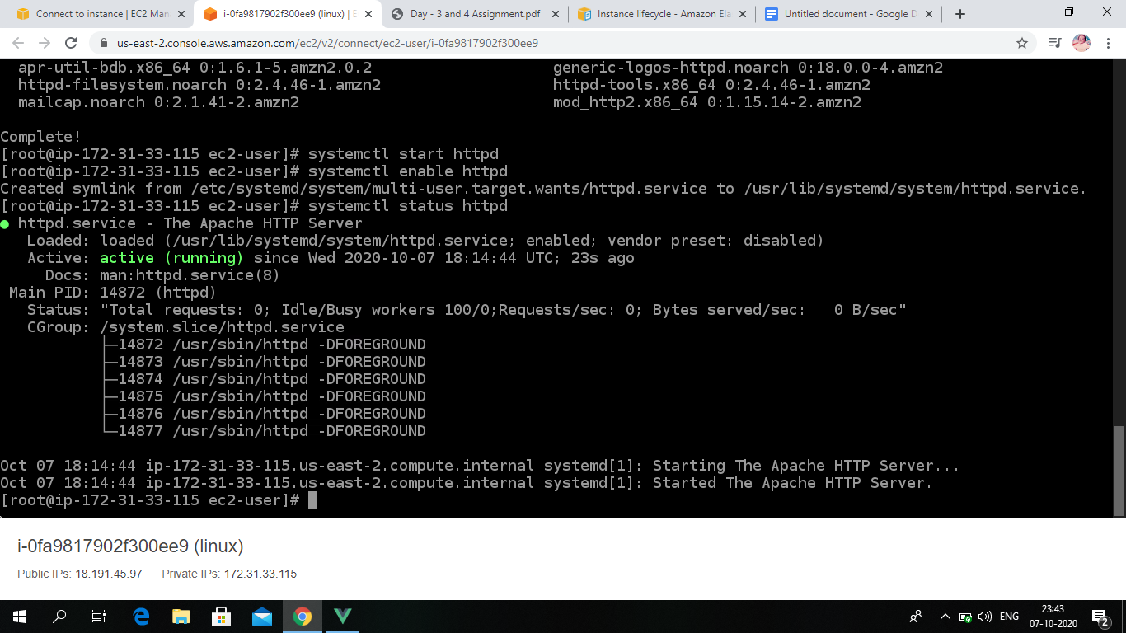

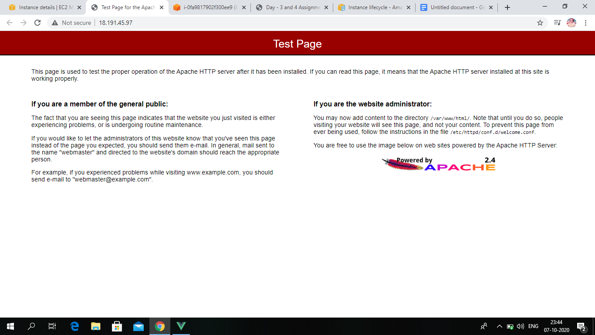

PROJECT 5:

Working with S3

a.working with S3-.jpg

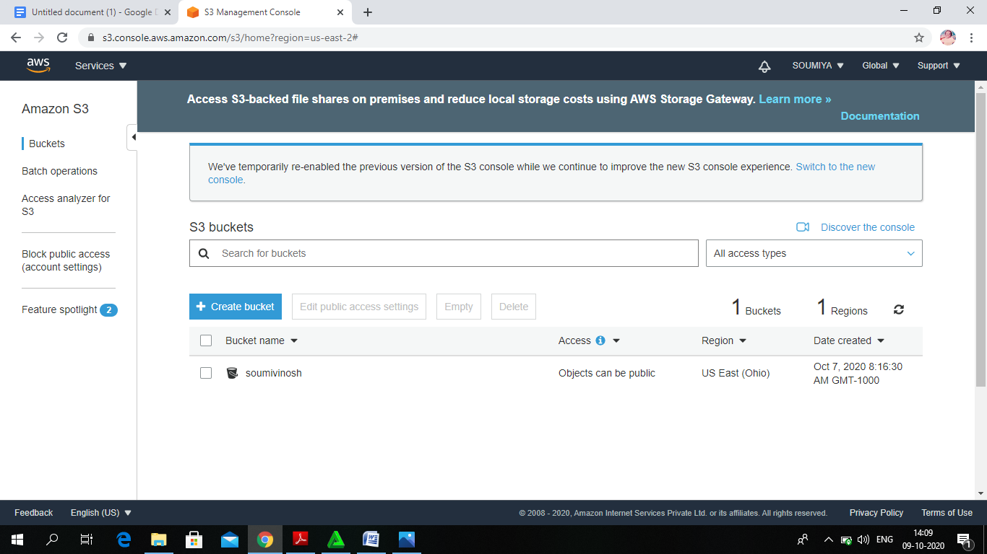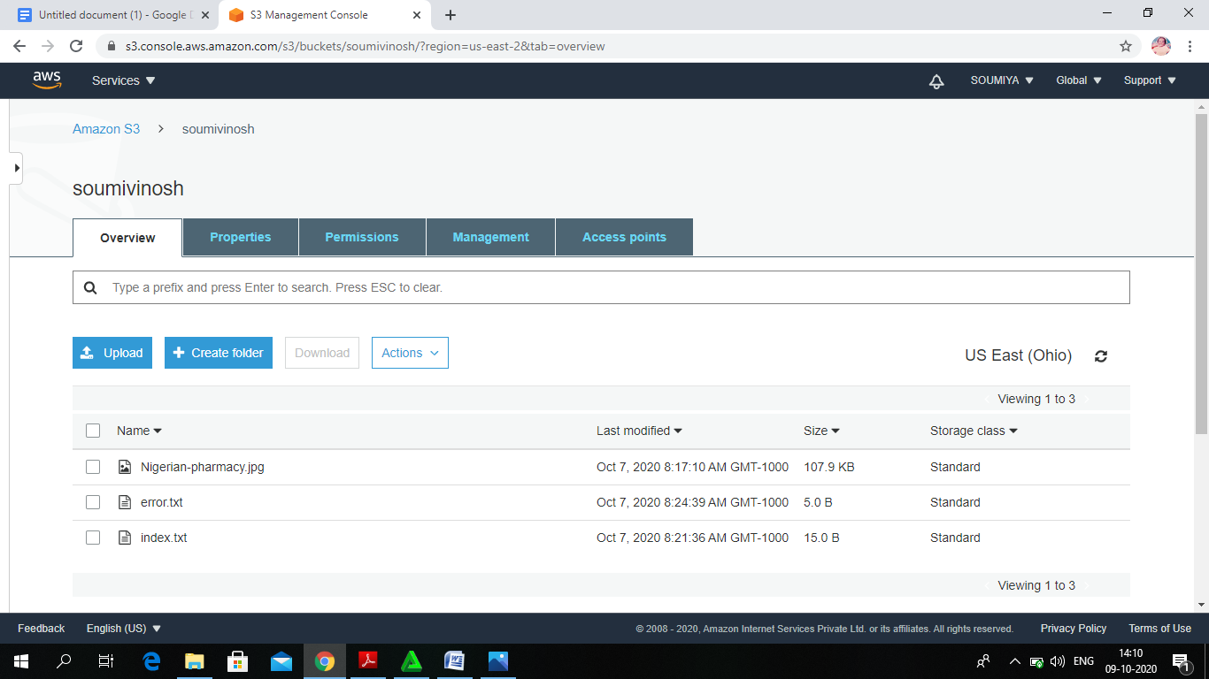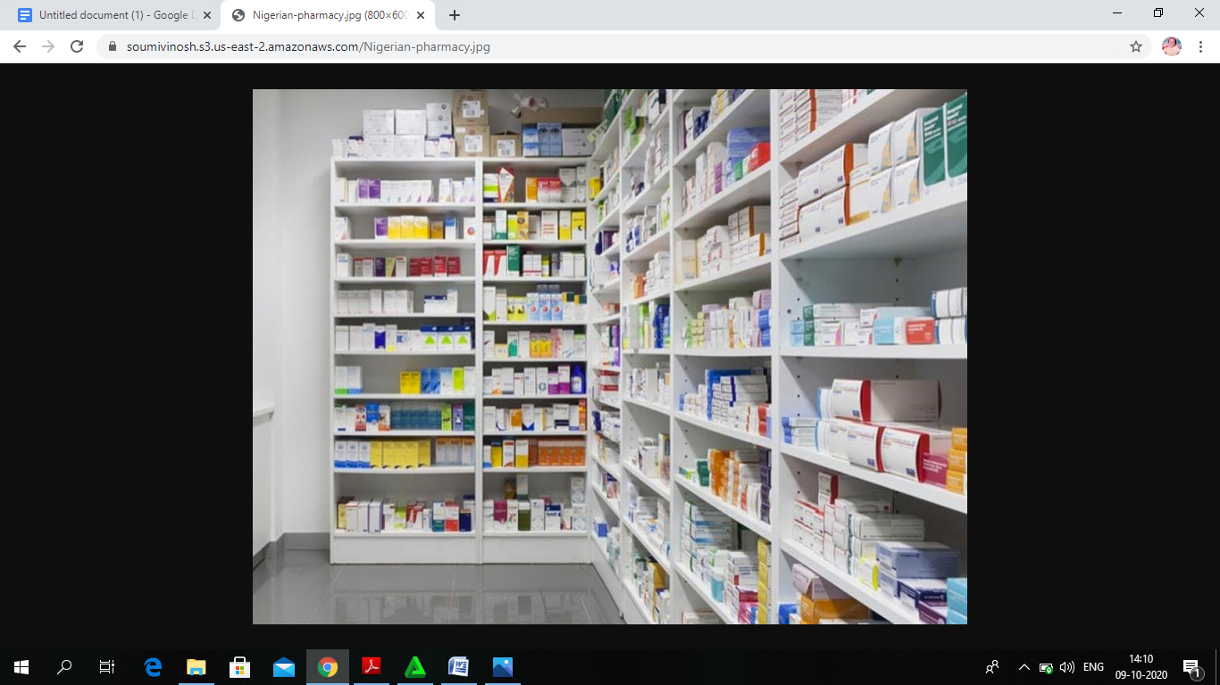

b.static web hosting



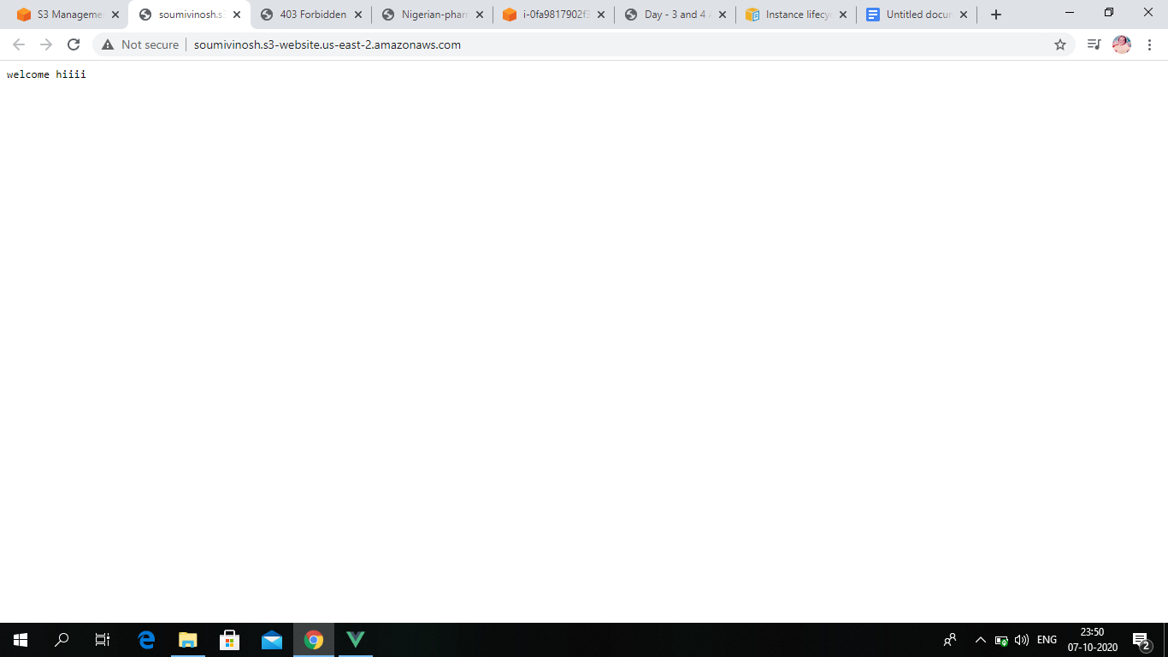

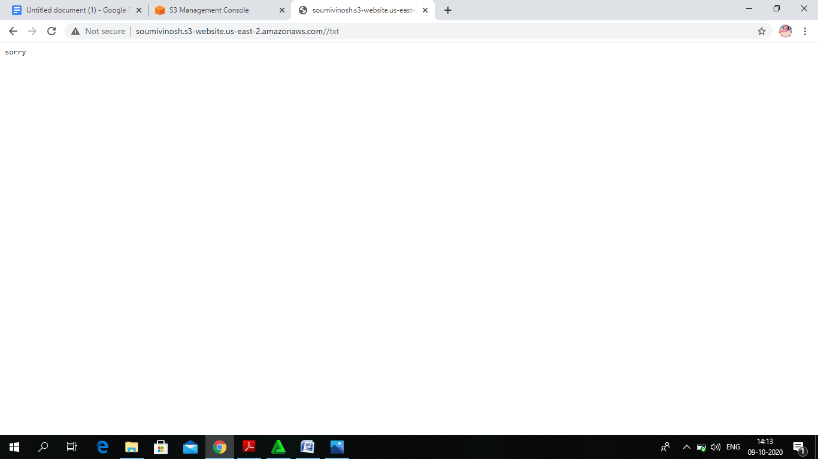

c.Versioning

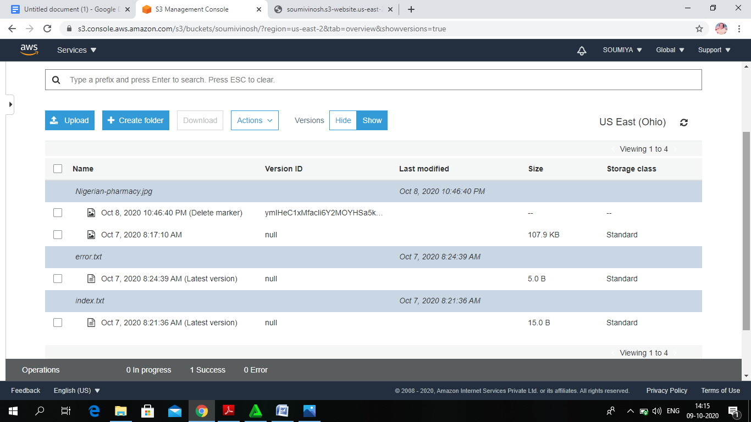

**QUESTION 1:**

**Explain life cycle effects on instances:Stop,start,reboot,terminate-public IP,Private Ip,Applications**

**installed.**

**Life cycle effects on instances :**

STOP and START :

We move the instance to a new host computer (though in some cases, it remains on the current host).

When an EC2 instance is stopped using the stop-instances command, the following is registered at the OS level:

* The API request will send a button press event to the guest.
* Various system services will be stopped as a result of the button press event. **systemd** handles a graceful shutdown of the system. Graceful shutdown is triggered by the ACPI shutdown button press event from the hypervisor.
* ACPI shutdown will be initiated.
* The instance will shut down when the graceful shutdown process exits. There is no configurable OS shutdown time.
* If the instance OS does not shut down cleanly within a few minutes, a hard shutdown is performed.

**REBOOT**

An instance reboot is equivalent to an operating system reboot. In most cases, it takes only a few minutes to reboot your instance. When you reboot an instance, it keeps its public DNS name (IPv4), private IPv4 address, IPv6 address (if applicable), and any data on its instance store volumes.

Rebooting an instance doesn't start a new instance billing period (with a minimum one-minute charge), unlike stopping and starting your instance.

**TERMINATE**

you can delete your instance when you no longer need it. This is referred to as *terminating* your instance. As soon as the state of an instance changes to shutting-down or terminated, you stop incurring charges for that instance.

**PUBLIC IP**

A public IP address is an IPv4 address that's reachable from the Internet. You can use public addresses for communication between your instances and the Internet. Each instance that receives a public IP address is also given an external DNS hostname; for example, ec2-203-0-113-25.compute-1.amazonaws.com .

**PRIVATE IP**

A private IPv4 address is an IP address that's not reachable over the Internet. You can use private IPv4 addresses for communication between instances in the same VPC. For more information about the standards and specifications of private IPv4 addresses,